St. Mary of the Woods Horn Community Center Member Policy
Contact Information:
Manager Renee Boehman Office (270) 233-5405
Email hcc@stmarywoods.com

Anyone wishing to sign up for a membership should set-up an appointment with the Business Manager of the Horn Community Center. All members and guest must sign the required waiver and release of liability form prior to using the facility.

Hours of Access: Standard & Student Members 4:45 AM until 10 PM
Premium Memberships 24/7 Access to the Horn Community Center.

Fee’s: Members must be paid in full to be considered active members and use the facility.
Memberships: Premium Standard Guest
Monthly $15 $10 $5
Year $175 $115 N/A
Staff Memberships- All staff members of St. Mary of the Woods Catholic Church, St. Mary of the Woods School, Trinity High School, and the Horn Community Center will have a free Premium membership to the facility. Staff can purchase memberships for spouse and children that are in school (K-college) ½ price. All members including staff will have to purchase their key to get into the facility.
Specials- At any point in the year, the Business Manager of the Horn Community Center may offer a special price on memberships. Any member with a year membership may purchase their following years membership at this rate only while the special is going on. (For example Fr. Brian’s membership will expire May 1, 2019. If there is a special going on January, 2019, Fr. Brian can buy the next year of his membership in January and his new expiration date will be May 1, 2020.) Families are limited to 1 discount per year.
Payments- Any person signing up or renewing a month to month membership must sign up for automatic withdraw. Members signing up for a year membership may pay in cash, check, or with a card. Any annual payments paid with a card will add a $3 Transaction fee. Checks that bounce back will add a $35 fee to account that must be paid prior to becoming an active member. Once a payment is made gift cards/discounts will only be accepted to extend the membership length. Payments will not be returned unless it is a mistake made by Horn Community Center Employee.
Standard Membership: Standard Members will have access to the Walking Track, Fitness Center, and Member Locker Rooms. Cards will also be restricted to only access the building from 4:45 am-10 pm. Standard Members will not receive any discounts on St. Mary of the Woods Horn Community Center events. Standard Members must be 18 years old.
Premium Membership: Premium Members will have access to the building 24/7. If the Key Fob System goes out this will be cut down to the same time as standard members. Premium Members will have access to the courts when they are not used by Trinity, St. Mary, and any other event hosted by The Horn Community Center. Premium Members are eligible to receive discounts on events, classes, and leagues. These discounts will be promoted with the event and must be approved through the Business Manager of the Horn Community Center.
Guest Membership- Guest memberships will receive the same privilege as the member whom they come with. However, they will not receive any of the discounts for events or leagues. All Guests must be accompanied by an active member of the Horn Community Center at all times. Guest Memberships must be purchased and paperwork signed prior to use of facility. The Business Manager must approve of a guest membership. It should never just be slide underneath the door.
Keys/Fobs: All Members must purchase a key card or fob. Key cards cost $5 and key fob cost $10.
Members should always scan in at the fitness center door. Members are to never let someone without an active membership into the gym including a guest. Anyone that lets an individual into facility without an active membership will be held liable to pay for any damage caused including but not limited to a lost guest membership fee.

(If the card system goes out ALL members will only have access from 4:45 am-until 10pm.)

Cancellation Policy- Members must give notice of cancellation via e-mail to the Business Manager of the Horn Community Center at least (30) business days prior to the scheduled monthly debit. Late cancellations may result in a charge of one full month membership. If by reason of death or disability any contract between the Horn Community Center and member should be waived. Any prepaid sum shall be returned. The Business Manager has the final say on all ending memberships and any prepaid balance.
Member Policies: An honor system is used for the use of the facility. Everyone is expected to follow the policies and rules of the St. Mary of the Woods Horn Community Center. It is the member’s responsibility to report any accidents or misconduct within 2 business days of incident. Failure to follow these policies and procedures can result in the termination of membership.
Members shall be deemed in default of this agreement upon the failure to comply with any of the terms and conditions of this agreement, including but not limited to, the obligation to make payments as when they are due. Upon default the Horn Community Center shall have all rights and remedies available to it, including termination of this agreement and institution of an action for all applicable damaged pursuant to this agreement. The Business Manager of the St. Mary of the Woods Horn Community Center has all rights to terminate and reject any membership at any time for any reason
Parking: can be very limited at the Horn Community Center. Everyone should park in between two white lines in either the Horn Community Center or St. Mary Gym lot. Any ticket or towed car is the responsibility of the individual.
Facility Rules:
- We highly recommend that members use a buddy system in order to promote a safe environment.
- All use of the equipment is done at the member’s sole discretion as no training or other supervision will be provided by the Horn Community Center.
- Use of Alcohol and/or Tobacco is not permitted on site.
- Members are expected to wear appropriate attire. Shoes and Shirts are required at all times outside the locker room. Members must have shoes that fully enclose the entire foot and do not mark the floor.
- Members should only use what they have access to with the membership that they purchase. For example, courts are only for premium members. If a standard member is caught using courts they must upgrade membership or pay a $20 usage fee per time of court use.
St. Mary of the Woods Horn Community Center will have other events that take place in the facility. Members will be restricted to the fitness room during these events. Members should never use their key card to let themselves into the facility for an event. Members found using a card for such purpose will be suspended from the facility until they meet with the Business Manager of the Horn Community Center.
Enforceability: The Undersigned parties agree that if any provision or portion of this agreement is declared void and unenforceable, such provision or portion of a provision shall be deemed served form this agreement, which shall otherwise remain in full force and effect. Further, if any such provisions or portion of a provision may be reduced, and/ or narrowed in scope, such provision or portion of a provision shall be reduced or narrowed and so enforced. Members specifically waives any right of any type which would invalidate the enforceability of any provision or portion of this agreement.
Governing Law: This agreement shall be governed and enforced in accordance with the Laws of Kentucky.
Members prior to 7-1-19: Any member that had an active membership prior to 7-1-19 will be considered a standard member with premium time access. If they let membership expire they will be required to upgrade to current membership. Any past member that upgrades to a premium may not downgrade back to this grandfather policy.
Horn Community Center Tobacco Free Policy (Effective March 1, 2020)
St. Mary of the Woods Catholic Church, School, Horn Community Center and Trinity High School are Tobacco Free. The use of tobacco and/or alternative nicotine or vapor products as defined in KRS 438.305 is prohibited in or on any property owned. This pertains to all sponsored events and all activities such as sporting events, concerts, receptions, fundraisers and picnics.

Contact Sheet and Member Agreement
Head of Household
Name: _____________________________________ Date of Birth: _____/_____/______ M/F
Address: ____________________________________ City: ________________ Zip code: ________
Phone: (_____)-______-_______ Email: ________________________________________________
Membership (circle one) Premium ($15/$175) Standard ($10/$115) Student ($5/55)
Key- Card ($5) or Fob ($10) Employee of School (Yes/No)
(Members choosing to paying monthly must give a routing and account number.)
By signing below, I acknowledge and agree with the terms and conditions of the St. Mary of the Woods Horn Community Center policies. I agree to abide by them and any new policy put in place by the director. I acknowledge that failure to comply with any of the policies will result in immediate termination of my membership without refund. I agree to pay all cost associated with any damage including any attorney fees and any reasonable expense the St. Mary of the Woods Horn Community Center occurred due to member or members action.
Member Signature __________________________________
Member Printed Name _______________________________ Date ____/ _____/ ______

Family Member #2 (only add if different from head of house)
Name: _____________________________________ Date of Birth: _____/_____/______ M/F
Address (if different from above): _________________________________________________________
City: _______________________________________________ Zip code: __________________
Phone: (______)-_______-__________ Email: _______________________________________________
Membership (circle one) Premium ($15/$175) Standard ($10/$115) Student ($5/55)
Key- Card ($5) or Fob ($10) (Student Members will not receive key cards to facility)
By signing below, I acknowledge and agree with the terms and conditions of the St. Mary of the Woods Horn Community Center policies. I agree to abide by them and any new policy put in place by the director. I acknowledge that failure to comply with any of the policies will result in immediate termination of my membership without refund. I agree to pay all cost associated with any damage including any attorney fees and any reasonable expense the St. Mary of the Woods Horn Community Center occurred due to member or members action.
Member Signature __________________________________
Member Printed name _______________________________ Date ____/ _____/ ______

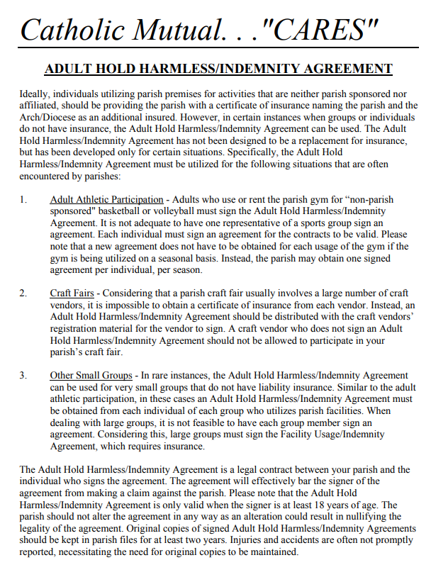
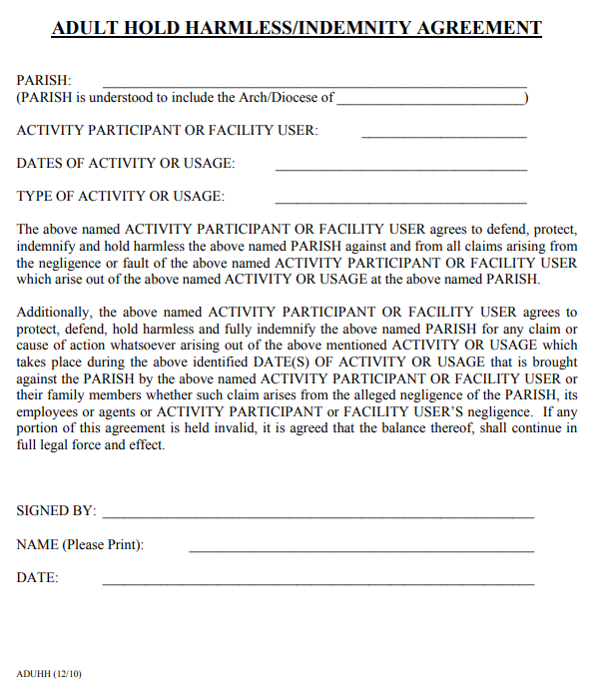

Month to Month Members

As of 7-1-2019 any membership that pays for less than 1 year must have a routing and account number on file. After the routing and account information is put into our processer and linked to your account the bottom half of this paper will be shredded.

Sign up date _____________

Bank Name_______________________________________________________

Routing number___________________________________________________

Account Number___________________________________________________

Expiration Date ________________ Security Code___________

Withdraw date requested ______________ (If different than start date members will still be charged for Cards/Fobs along with the prorated amount. Please note it take 2-5 days to process you will not see it on your account on the day you choose.)

Billing Address if different from physical address.
_______________________________________________
City____________________________________________
State _________________ Zip Code: _________________

Signature _____________________________________

